**THE CRM**

|  |
| --- |
| [MJ Logistics Gaming Company] |
| The CRM |
| [D284 Software Engineering] |

|  |
| --- |
| [Diljot Singh]  5-15-2024  [Version 1.0] |

Contents

A. Introduction 3

A1. Introduction and Purpose Statement 3

A2. Overview of the Problems 3

A3. Goals and Objectives 3

A4. Prerequisites 3

A5. Scope 3

A6. Environment 3

B. Requirements 4

Business Requirements 4

User Requirements 4

Functional Requirements 4

Non-Functional Requirements 4

C. Software Development Methodology 4

C1. Advantages and Disadvantages 4

Advantages of the Agile Method 4

Disadvantages of the Agile Method 4

Advantages of {A Different Method} 4

Disadvantages of {A Different Method} 4

C2. Best suited 5

D. Create Two Representations of the Software Solution 5

Representation 1 5

Representation 2 5

E. Testing 6

Test Name 1 6

Test Name 2 7

Test Name 3 8

F. Sources 8

# Introduction

# A1. Introduction and Purpose Statement

The CRM provided is a web-based CRM to improve MJ Logistics Gaming Company’s management of its existing systems and add functionality. The purpose is to provide a scalable, easy to use and user-friendly system that performs all the necessary functions needed. The CRM provides a lot of functionalities that are beneficial for MJ Logistics Gaming Company including Custom Reporting, intuitive order tracking. And CRM provides the two-way communication between CRM and Microsoft Outlook for efficient communication.

# A2. Overview of the Problems

The company’s last two-year sales has been up by 42%, while they have using the same traditional models for Customer Management. This is making the basic operations of the company slow as the functionalities used by the traditional methods are outdated. The proposed CRM provides new and latest technology services like virtual systems and automated order tracking and data logs. With the proposed CRM, the information needed will be available on fingertips. The data will be more secure using CRM as it hosts cloud-based storage instead of physical storage.

# A3. Goals and Objectives

The goal of the CRM system is to provide the company with a scalable system that meets the reporting requirements. The objective of CRM to fulfill this goal is using and installing AWS cloud server so the company’s server resources are expandable in the future whenever needed.

The other goal of the CRM is to provide a simple, easy-to-use and user-friendly interface to while performing necessary operations. The objective of CRM regarding this goal is to create a User Interface for every dashboard which is easy to use while providing adequate performance. The example of this User Interface is provided on page 8 under CRM representation.

# A4. Prerequisites

List the prerequisites, their descriptions, and future completion dates. Be sure to be clear and concise for all listed prerequisites. (You may add lines for additional prerequisites if needed.)

|  |  |  |  |
| --- | --- | --- | --- |
| Number | Prerequisite | Description | Completion Date |
|  |  |  |  |
| 1 | Operating System | Upgrade the operating system to latest Windows 11 for every working computer in the company. Ensure required Microsoft 365 bundle for Outlook is installed on every computer. | May 20th, 2024 |
|  |  |  |  |
| 2 | AWS cloud server | Move the company’s server to an AWS cloud server. This ensures flexibility and scalability in the future. | June 20th, 2024 |

# A5. Scope

The Customer Management System will cover these requirements: Multiple concurrent user support, Report creation, Custom report creation and viewing, implement ‘soft delete’ and ‘hard delete’, filter the reports, Track orders, place and create new orders, track sales, track meetings, ensure two-way communication between CRM and Microsoft Outlook.

The requirements not covered by CRM are Contact management, Ticketing system, Contracting, Opportunity management, Hosting, Data types, Quoting and Forecasting.

# A6. Environment

The program is deployed in cloud-based distributed system using Amazon’s AWS. Storage of the system is also kept virtual for scalability using Amazon S3. All the computers are connected to each other using Amazon’s VPC. Due to this, there are minimal maintenance periods. Amazon’s web services are highly reliable, and they provide satisfactory and quick support whenever there is an issue. The proposed CRM is tested using Amazon’s EC2 to create virtual systems.

# Requirements

## B1. Reporting requirements

The Reporting is central to our CRM system. It provides UI interface to view custom reports. Reports can be filtered, formatted and exported based on stakeholder’s needs. The user can view previously generated reports because the functionality allows to store the reports already generated.

## B2. User Requirements

The User requirements are satisfied to make it easier to work with the platform. To start with, the platform should handle at least 500 users concurrently accessing the system. Because of the usage of AWS, it offers scalable and fast infrastructure that can dynamically resources based on demand. It is also made sure that the system is equipped to be used with latest OS and browsers.

## B3. Functional Requirements

The functional requirement met by the CRM is Order Management. The user will be able to view a quote and turn it into a sale. The real-time order tracking and re-ordering are supported by the system. The system has all-in-one functionality needed for order management by the user.

## B4. Non-Functional Requirements

The functionality to delete or remove the data is important to properly manage the database. The user will have the option to do a ‘soft delete’ or do a ‘hard delete’ of the data. The ‘soft delete’ will delete it from the current view and not actually delete the record or data item from the system. This can be done to make the data view simple and easy to understand by removing items that are not needed at the current point of time, for example, when viewing a report. The ‘hard delete’ will completely delete the data from the system. To prevent un-intentional deletion of data, a set of permissions and requirements are imposed on the user to perform this functionality. Any user who performs a ‘hard delete’ will have to have a set of permissions that will be provided through the role of that user.

## B5. Sales tracking

The CRM system provided has the functionality to track sales and meetings between stakeholders and other employees of the company. It does that by maintaining a log of all the meetings that took place in the company. The feature also tracks the sales made by the company. Two-way communication between the CRM and Microsoft Outlook is provided to ensure continuous communication.

# Software Development Methodology

# C1. Advantages and Disadvantages

## Advantages of the Agile Method

1. Flexibility: Agile methodology is known for its flexibility. It is beneficial for our CRM systems as it allows adjustments to be made based on stakeholder’s feedback and everchanging business needs (Agile vs Waterfall, 2021). Like changing reporting formats or adding new order management features.
2. Self-organizing: The Agile method allows various teams to be self-organizing and allocate resources according to their individual needs. This allows the faster delivery of new products and features as upper management is not directly involved in resource allocation (Agile vs Waterfall, 2021). The upper management can provide feedback on the product parts that are delivered every week, or a few weeks based on the timeframe used. For our CRM system, this allows faster delivery of the features like resolving order management issues.
3. Incremental delivery: As the agile method allows the product to be delivered in small parts and incremental iterations, we can deliver high-value features first, such as reporting capabilities and order management functionalities, while continuously working on all the features to enhance the functionality using user feedback.

## Disadvantages of the Agile Method

1. Loose planning: The agile method involves loose planning and abstract high overview of the final product (Agile vs Waterfall, 2021). This can lead to unpredictable results as more and more changes are made to improve the new CRM system. This can lead to deviation from initial product requirement and refers to as Scope Creep.
2. Resource extensive: In Agile methodology, the whole development team is divided into multiple teams with their own scrum master and product owner. This can be resource extensive as the size of project increases with more scalability as more and more people are required compared to other methods. The starting cost for Agile is higher compared to other methods as it is a fairly new methodology and everyone in the process needs to be trained on how it functions (Agile vs Waterfall, 2021).
3. Lack of documentation: While Agile promises faster delivery and responsiveness to change, it poses challenges to maintain detailed documentation, such as report specifications and order management requirements which can lead to functionality problems in our CRM system if not checked carefully.

## Advantages of the waterfall method

1. Minimal Scope Creep: In Waterfall method, the product’s specifications and requirements are well defined and checked at every checkpoint (Agile vs Waterfall, 2021). This allows the step-by-step development of our CRM system and ensures that nothing is left out and the development meets the stated requirements. For example, it ensures that the reporting capabilities are met before jumping to non-functional requirements like ‘soft and hard delete’.
2. Easier to understand: For some employees, the old school structure of the waterfall method is easier to understand and work with (Agile vs Waterfall, 2021). There is very minimal need to train employees about the structure and process of waterfall method. This saves resources on training employees and hiring trainers and provides the development of our CRM system an instantaneous start.
3. Budget prediction is easier: The financial budget and resources needed can be easily and accurately predicted in case of Waterfall method. As the project follows a systematic and pre-defined plan, it is easier to compute costs and timeframe expectations. This enables the vendor to provide a more accurate deadline for the CRM system and its deliverables.

## Disadvantages of The waterfall method

1. Low flexibility: The Waterfall method has very limited flexibility (Agile vs Waterfall, 2021). This results in low creativity solutions as team members do not have much room to make changes as they feel fit.
2. Longer time to delivery: New technologies are coming out almost every month. But, a multi-month project with this approach will require to repeat all the steps all over again in case of addition of a new feature or technology. This can delay the main functionalities like reporting capabilities and order management even if a new lower functionality support feature is introduced in the market like ‘soft delete’ and ‘hard delete’.
3. No early testing phase: There are no early testing phases in the process of development of the project. This can lead to problems as changes discovered during the testing phase may require significant rework (Agile vs Waterfall, 2021). This will delay deadlines and results in dissatisfied users. In our CRM system, if we do not test each section of the requirement after completion of that feature, we might face problems when we try to run tests on the whole system all together. This results in significant delay as we will have to go through each step of the waterfall method again.

# C2. Best suited

The methodology that will be used for this project is Agile methodology. Both Agile and Waterfall methods have their advantages and disadvantages. But because we are working with a new feature and new functionalities, there is a higher chance of changes being made on the way. Agile method known for its flexibility to spontaneous changes in goals and requirements, provide optimal environment and structure for the development of our CRM system. Agile method may seem costly at the start, but it is cheaper in the long run, especially in the case of changing final products functionalities.

# Create Two Representations of the Software Solution

*Note: You may add subsections here to fit the needs of the solution. At least two different representations of your design need to be present.*

## Flowchart of the CRM SYSTEM

Flowchart of the CRM system


The above flowchart shows the workflow of our CRM system. It shows how user can login and accesses the Reporting Dashboard, from there, user can generate custom reports, navigate to Order management or navigate to Sales Tracking dashboard and perform the operations.

## Reporting UI

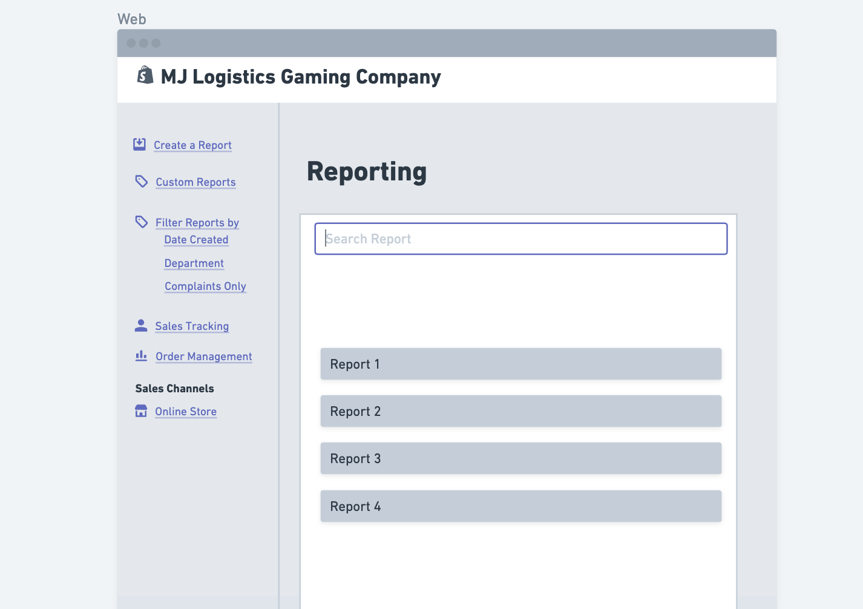

The above picture shows the UI that our CRM system will have. It enables user to create a report, and custom reports. The filter feature is also provided to filter reports by “date created”, Department or if the user only wants to see Complaints. Links are provided to navigate to the Sales Tracking and Order Management dashboards. Sales Channels is an extra feature whose planning is still in discussion stage with the company.

# Testing

# Custom report test

|  |
| --- |
| Requirement to be tested:  If the Custom Report feature generate a custom report following according to the filters provided. |
| Preconditions: The system is able to create custom reports and previously made custom reports exist. |
| Steps:   1. Create a custom report using the filters provided and name it ‘custom1’ and save it. 2. Create another custom report using different filters and name it ‘custom2’ and save it. 3. Search for the report using search bar and type in ‘custom1’ and hit enter. |
| Expected results: We see the newly created custom report ‘custom1’ and not any other report with the same name. |
| Pass/Fail: If we only saw the newly created custom report ‘custom1’ according to the filters entered, the test Passed. |

# Track order test

|  |
| --- |
| Requirement to be tested:  If an already existing order can be tracked using Order ID and if it successfully provides the status of the order. |
| Preconditions: Using Order ID, the system is able to find the status of the order associated with the order ID. |
| Steps:   1. Access the Order Management from the Reporting dashboard. 2. Select ‘Track Order’ option in the Order Management dashboard. 3. Enter the order ID of an existing order still in process in the ‘Track Order’ function. 4. Click Enter. |
| Expected results: The function will return the current status of the order that belongs to the order id entered. |
| Pass/Fail: If the feature successfully returned the correct Order’s status which was not delivered, using the Order ID provided that belongs to the correct Order, the test Passed. |

# COncurrent users affect on performance test

|  |
| --- |
| Requirement to be tested: If the CRM system is able to handle at least 500 users logged in at the same time. |
| Preconditions: The system is able to successfully log in 500 users at the same time with the adequate performance. |
| Steps: The steps the tester must execute to test the feature.   1. Log in one User1 and track the performance. 2. Have the User1 to perform basic functionalities like creating a report, custom report, etc. 3. Measure the performance and see if there are any issues with the report creation, order tracking, order creating, meetings and sales tracking and all the other features. 4. Repeat first three steps until the number of users reach 500. 5. Record any issues that might occur in the process and after adding 500 users. |
| Expected results: There will be no issues regarding performance and functionality of the CRM system. |
| Pass/Fail: If there were no issues in performance and stability of the CRM system while all 500 users performed basic functions simultaneously, the test Passed. |

# Sources

*Agile vs. Waterfall*. (2021, August 26). Pros, Cons, and Key Differences. <https://www.productplan.com/learn/agile-vs-waterfall/>